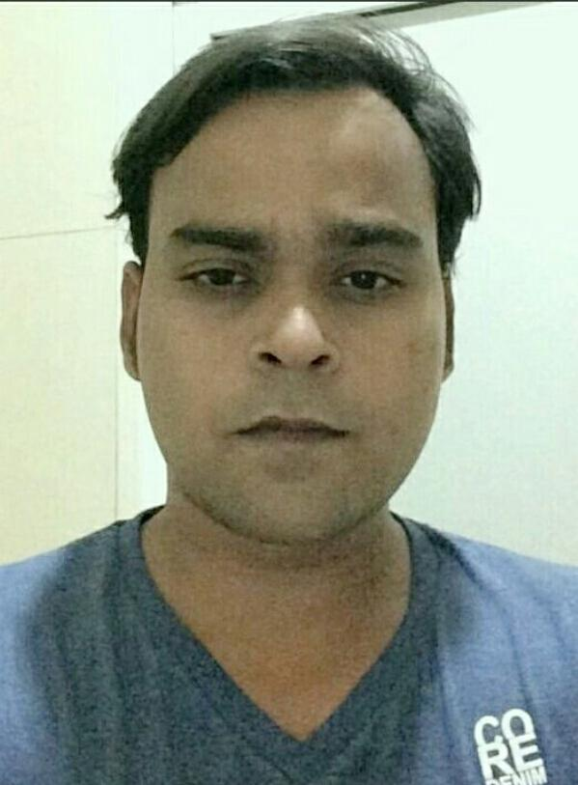Rohit Chaudhary Rajora

rohitcrajora@gmail.com
Villa no. 403, Omaxe Panorama City, Near SiegwerkPvt. Ltd., Bhiwadi, Alwar,
Rajasthan 301707
Mobile: 7023000179

CAREER OBJECTIVE

Dedicated, dynamic Electrical Engineer with a Bachelor’s degree and three years of relevant experience; seeking a full time permanent position in utility or equivalent department in a prestigious firm based on my credentials and abilities.

ACADEMIC DETAILS

- B.Tech. [2014] with aggregate of 73 from Institute of Engineering & Technology, Lucknow

- Intermediate [2010] with aggregate of 92 from Happy Blue Bird Public School, Shikarpur

- High School [2008] with aggregate of 96 from Happy Blue Bird Public School, Shikarpur

WORK EXPERIENCE

- Working as an Executive in Honda Cars India Ltd., Tapukara from Jul 2014 to till date

Role: Electrical Engineer - Utility
- Electrical LT and HT installation and commissioning in the shops of plant.
- Maintenance of LT motors and other rotary electrical equipment.

- Shift operation and maintenance of all the utilities.
- Operation and maintenance of LT and HT breakers (ACB, VCB, MCCB, MCB, MPCB etc.)
- Operation and maintenance of Protection relays and their auxiliaries.
- Project planning, execution and management. Designing of electrical power supply.

- Operation and maintenance of six number of 2000KVA DG sets.
- LUX level monitoring and designing.

- Ensuring the compliance of ISO 9001 and ISO 14001 in the concerned areas.
- Applying TPM to critical areas.
- Operation and maintenance of Sewage treatment plant and effluent treatment plant.
- Operation and maintenance of Screw and centrifugal air compressors.
- Operation and maintenance of cooling towers and air washers.

PROJECT DETAILS

• Electrical LT installation

Description | : | Designing and supervising the installation and commissioning of LT electrical distribution in weld shop, Plastic objects shop and paint shop of the plant as part of 180K expansion.
Duration | : | Six months
Role | : | Project In charge
Team Size | : | 60

• Air washers’ installation

Description | : | Installing, testing and commissioning of 15Nos. of air washers in the various shops of the plant
Duration | : | Four months
Role | : | Project In charge
Team Size | : | 20

• Ammonia Yard installation

Description | : | Installing, testing and commissioning of Ammonia Yard and its auxiliaries.
Duration | : | Five months
Role | : | Project Co-In charge
Team Size | : | 60

• Solar Power Installation

Description | : | Managing the installation and commissioning of solar power plant as part of PPA,synchronising the obtained power to the 11KV grid
Duration | : | Six months
Role | : | Project In charge
Team Size | : | 20

FIELD OF INTERESTS

- Electrical engineering

- Internet of things

- Electrical projects

SKILLS

- Electrical operation and maintenance

- Technical presentation skills

- Project planning and execution

- Electrical design

- MS-Office

ACHIEVEMENTS

- Timely completion of all the projects

- Implementing and running regular preventive maintenance activities of all the electrical equipment.

CURRICULAR ACTIVITIES

- Winner of TPM award at inter departmental level

- Carrying out regular technical and SOP training of technicians

- Inviting core electrical companies for in plant training

- Established freelance technical writer

- Proficient in Esperanto and German languages

- Freelance online tutoring to engineering students

STRENGTH & HOBBIES

- Total Quality Management

- Ability to learn quickly

- Good presentation skills

- Sound technical skills

- Sound IT skills

- Smart work management

- Learning about new technologies

- Reading technical books

- Learning new languages

- Planning everything ahead

REFERENCES

Sachin Shukla

Deputy Manager

Honda Cars India Ltd., Tapukara

sshukla@hondacarindia.com

9001294124

Gaurav Mathur

Manager - 1

Honda Cars India Ltd., Tapukara

gmathur@hondacarindia.com

8003018333

DECLARATION

I hereby declare that all the details furnished above are true to the best of my knowledge and belief.


Date : 30th March, 2018

Place : Bhiwadi

(Rohit Chaudhary Rajora)

